Lesson 5 Demo 16: Apply Node Labels, Inspect the Labels, and Filter Swarm Nodes by Labels

This section will guide you to:

* Apply labels to swarm nodes
* Inspect the node labels
* Filter swarm nodes by labels

**Step 1:** Apply labels to swarm cluster nodes

* Use the following command to list all the nodes in the swarm cluster:

*sudo docker node ls*

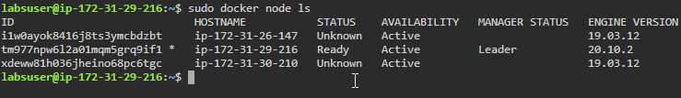

* Use the following command to add a label to a swarm node:

*sudo docker node update --label-add workerNode hostname*

***Note:*** *Replace hostname with IP address of Worker1 node*



* Use the following command to add multiple labels to a swarm node:

*sudo docker node update --label-add workerNode --label-add worker1 hostname*

***Note:*** *Replace hostname with IP address of Worker1 node*



* Use the following command to add a *typ*e label to identify nodes:

*sudo docker node update --label-add type=queue hostname*

***Note:*** *Replace hostname with IP address of Worker1 node*



**Step 2:** Inspect the node labels

* Use the following command to inspect a node for **Labels**:

*sudo docker node inspect hostname*

***Note:*** *Replace hostname with IP address of Worker1 node*

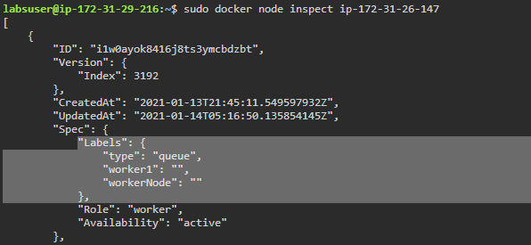

* Use the following command to inspect a node with a specific output format to get the node’s labels:

*sudo docker node inspect --format* ‘*{{ .Spec.Labels }}’ hostname*

***Note:*** *Replace hostname with IP address of Worker1 node. If you get any template error, you will need to replace single inverted commas (‘) with double inverted commas (“).*

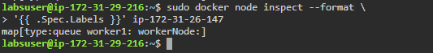

**Step 3:** Filter the swarm nodes based on Labels

* Use the following command to filter swarm nodes based on **Labels**:

*sudo docker node ls -q | xargs sudo docker node inspect -f '{{ .ID }} *

*[{{ .Description.Hostname }}]: {{ .Spec.Labels }}'*

